Usability Testing Report

StudySync – Student Study Planner App
Testing Objective
The purpose of this usability test was to evaluate how easily students could navigate and use the StudySync application. The study focused on task management, reminders, progress tracking, and overall user experience.
Test Tasks
- Log in to the application.
- Add a new study task.
- Set a reminder for an assignment.
- View upcoming deadlines in the calendar.
- Check weekly study progress.
- Navigate to the profile screen.
Participant 1 – Engineering Student
Participant 2 – Final Year Student
Participant 3 – Computer Science Student
Participant 4 – Engineering Student
Participant 5 – College Student
Record Observations
Participant | Observation
User 1 | Could not immediately find Add Task button
User 2 | Calendar was easy to understand
User 3 | Wanted larger navigation icons
User 4 | Found progress screen useful
User 5 | Suggested clearer labels
Metrics
Metric | Result
Task Success Rate | 90%
Average Completion Time | 2 Minutes
User Satisfaction | 4.5/5
Navigation Errors | 3

Design Iterations
Iteration 1
Problem:
Users could not easily identify the Add Task button.
Solution:
Increased button size and improved visibility.
Iteration 2
Problem:
Navigation icons appeared too small.
Solution:
Increased icon size and improved spacing.
Iteration 3
Problem:
Some users were unsure which navigation tab was active.
Solution:
Added color highlighting to the active navigation tab.
Before vs After Screens
Take screenshots from Figma.
Example:
- Before : Small Add Button
After : Larger Blue Add Button
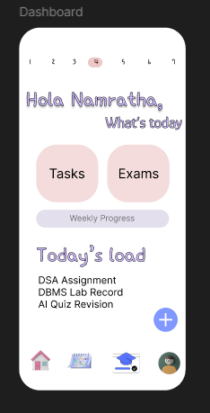

And:
- Before
All navigation icons same color
After
Active tab highlighted
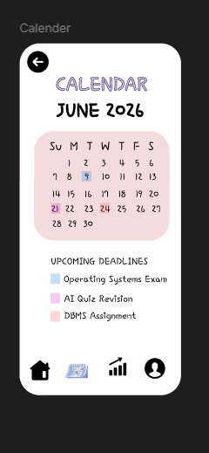
Conclusion
The usability testing helped identify minor navigation and visibility issues within the StudySync application. Based on user feedback, several improvements were made to enhance usability and accessibility. The final design provides a more intuitive and user-friendly experience for students.

